Every person is important. Our goal is to significantly improve the mental health and well-being of all members of the community through counseling, support, awareness and advocacy.

Our current practices for supporting this cause are offering supportive resources and prevention through education and awareness of this crisis. Our vision entails an interconnectedness among all available resources and awareness for those missing and encourage a healthy lifestyle for all involved by helping fmilies cope with grief to crimes in reality state-wide, nationally, and worldwide.

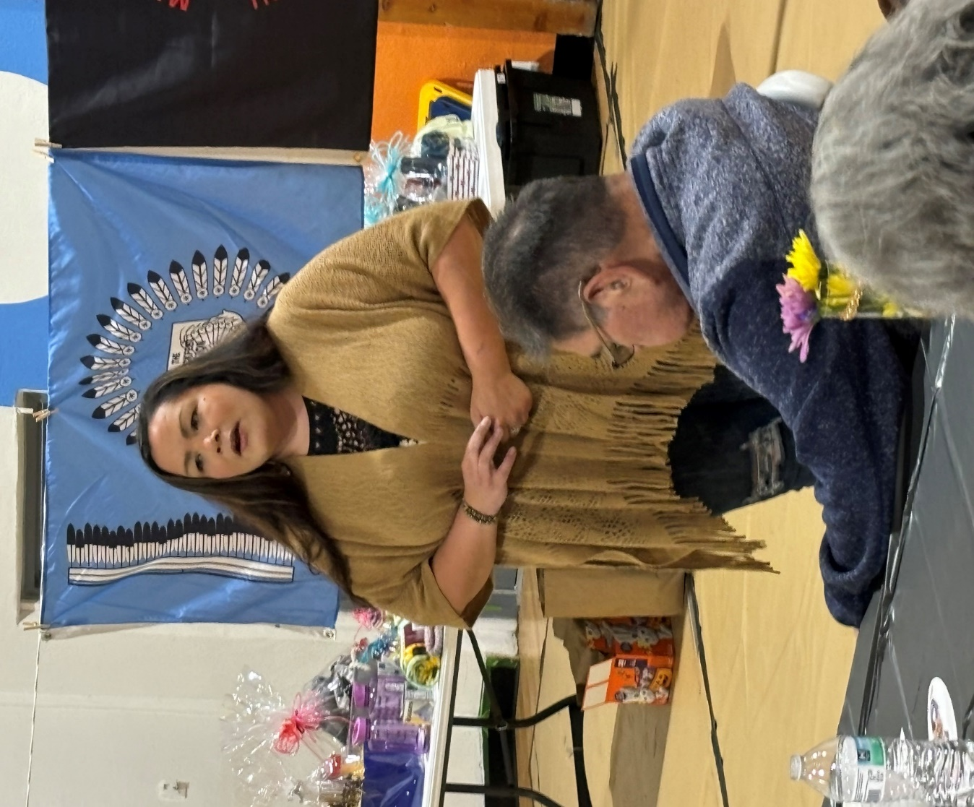

The goal is to work collaboratively, with the focus being, to empower and offer healing pathways, to help support family members of MMIP are recognized as true experts, because of their own lived experiences in the loss of a loved one.

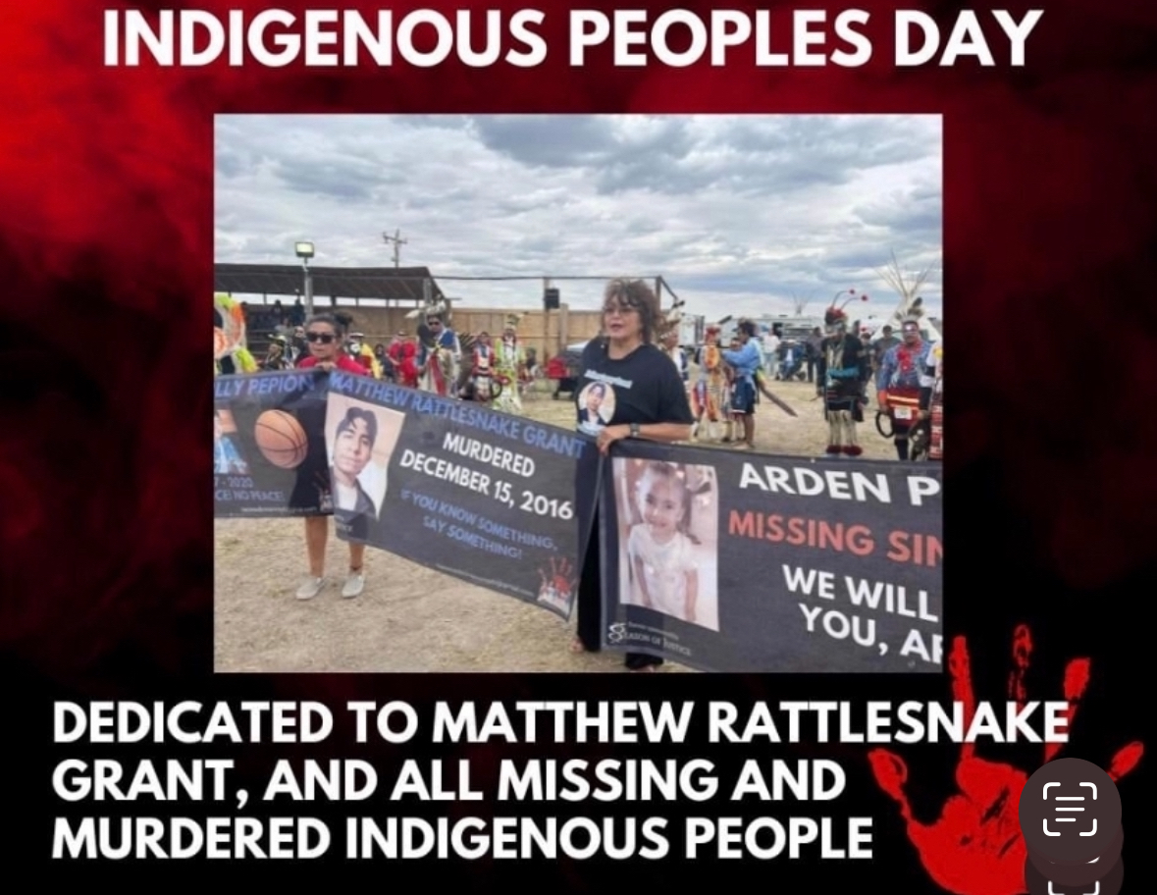

When we can come together with humility, sensitivity, and culturally appropriate connection, in a trauma-informed space, we can make changes to better the safety and circumstances for generations to Physical and verbal assaults on children. The National Center for Juvenile Justice found that 1 in 3 girls and 1 in 6 boys were sexually assaulted before the age of 18. A study by the National Center for Education Statistics found that 27.8% of students report being bullied during the school year. There were 424,066 entries into the FBI’s National Crime Information Center for missing or abducted children in 2018 alone.

Throughout the years, I have provided self-defense classes, our goal is to provide self-defense classes for kids that are both fun and interactive

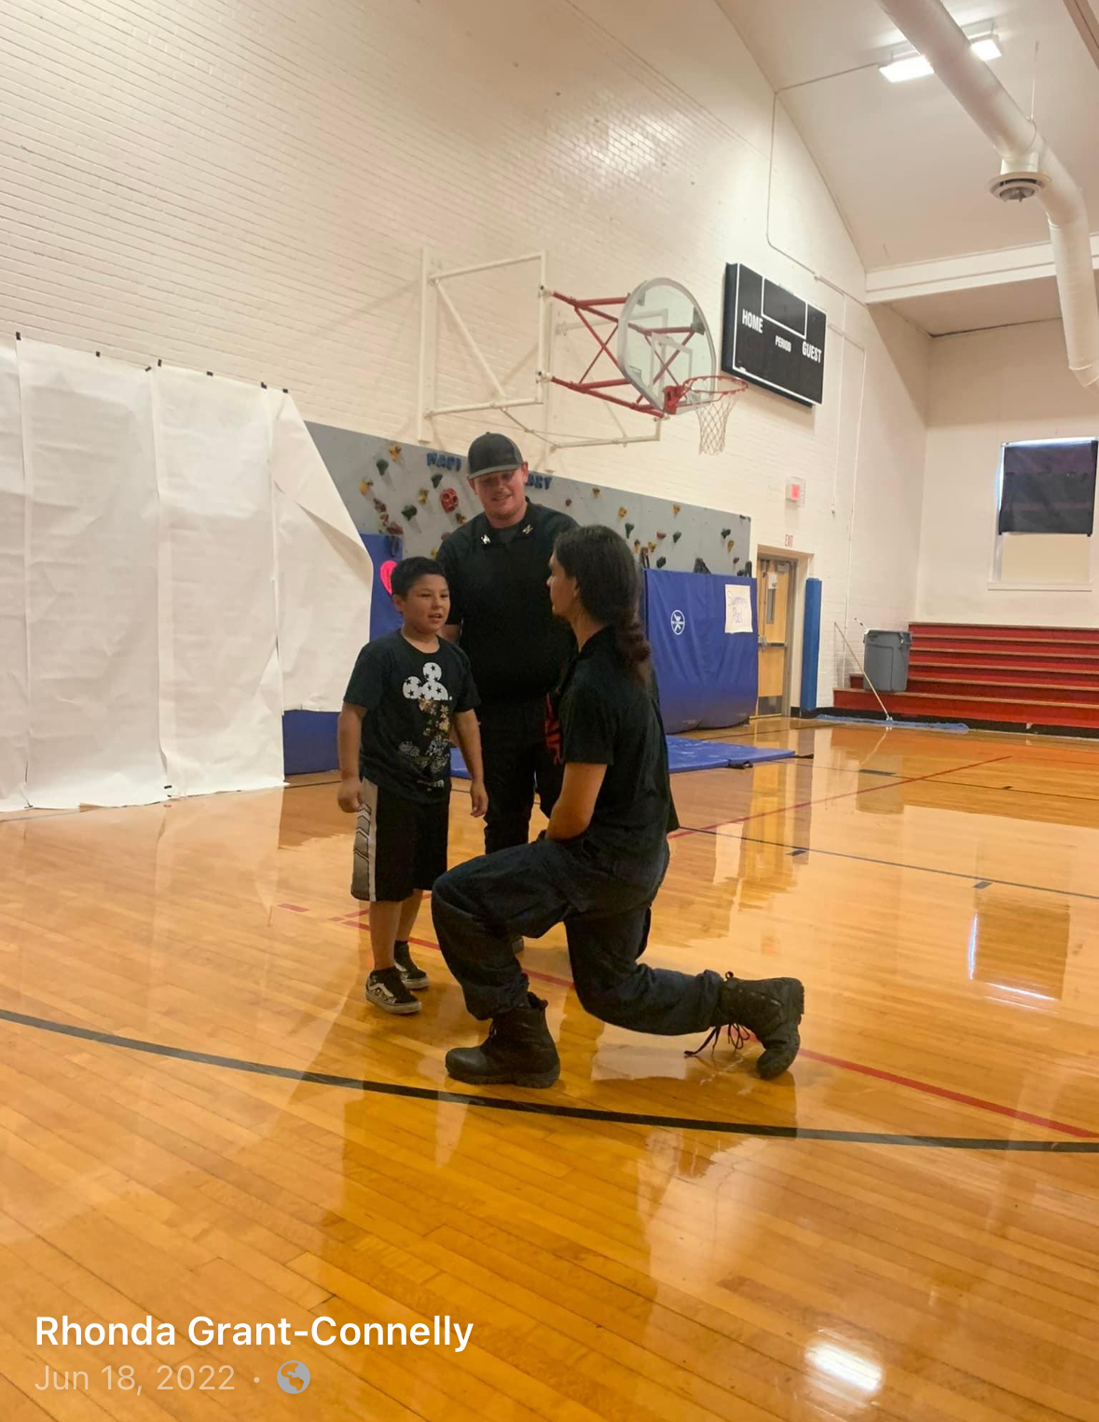

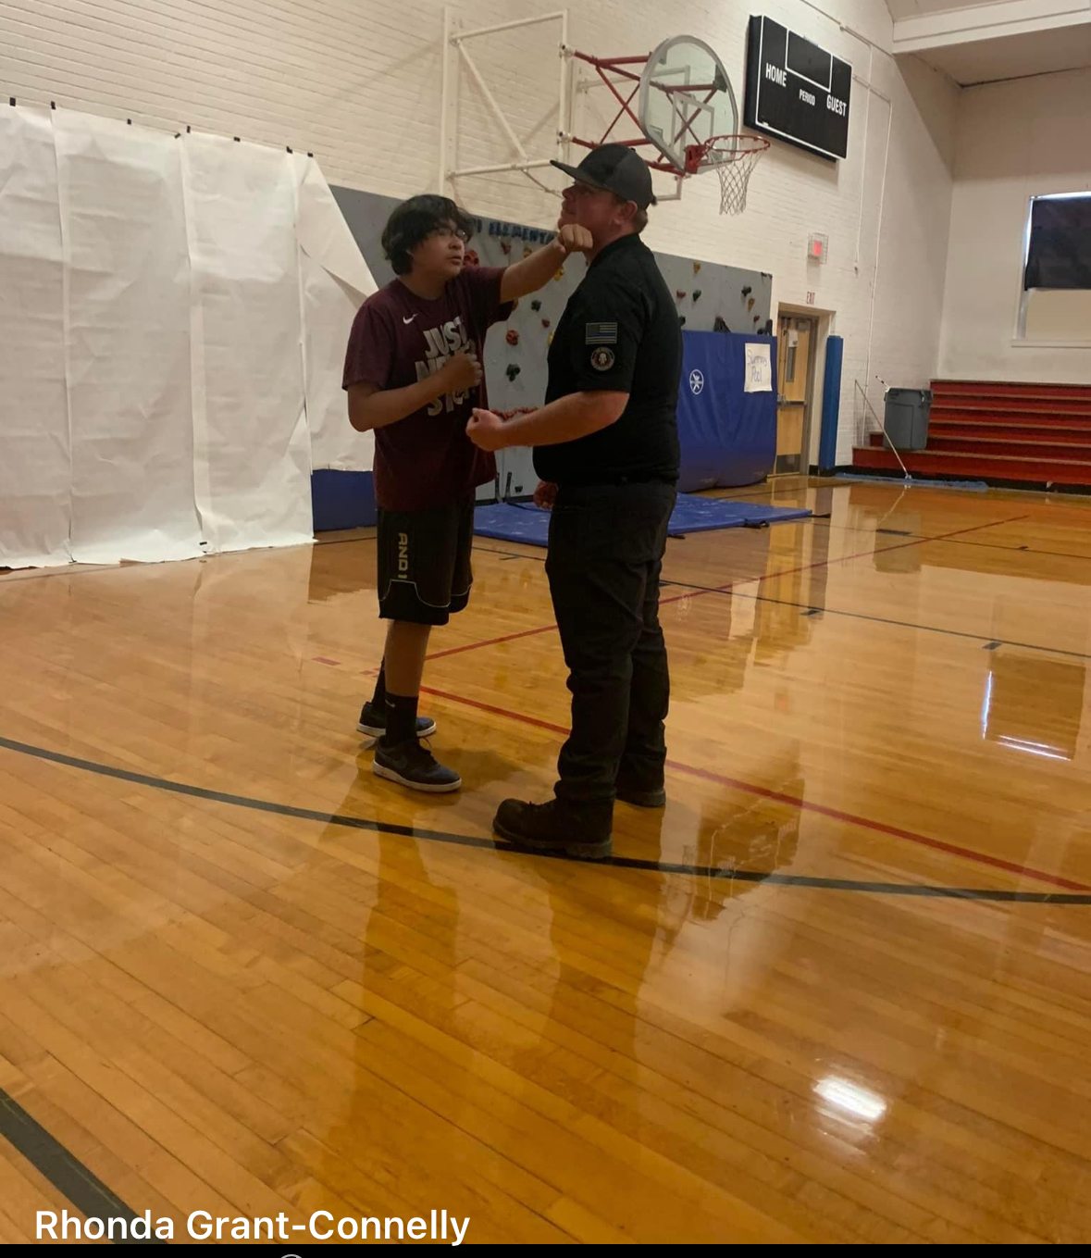
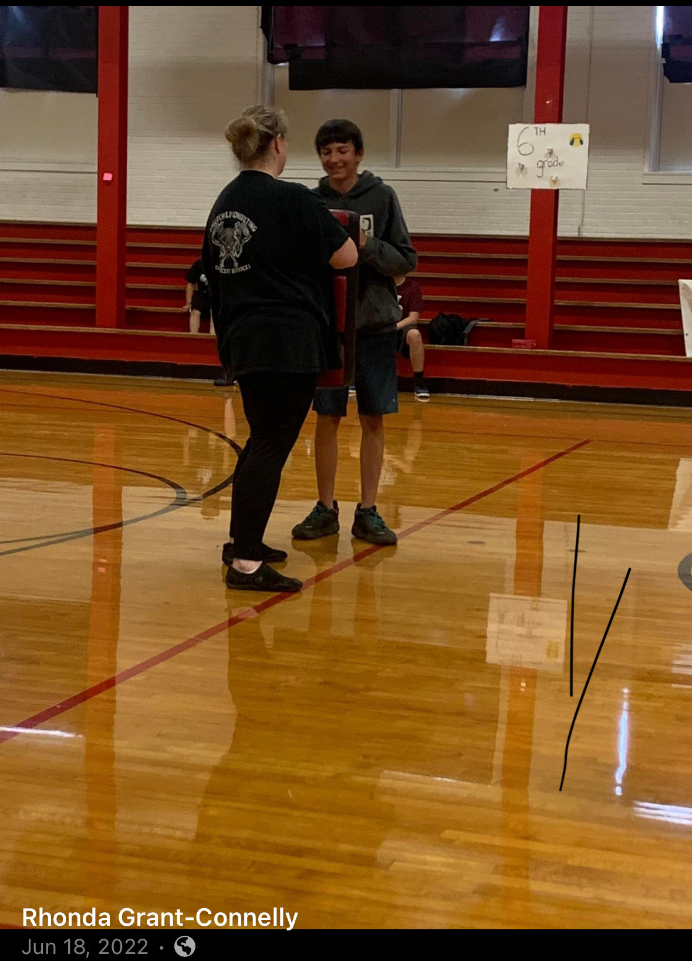
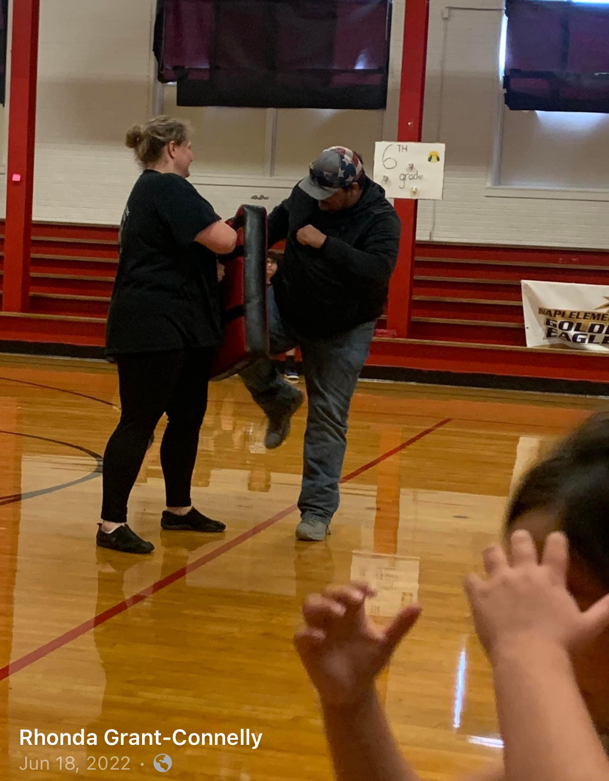
Our organization is for all neighboring reservations, and all nationalities. We have helped families on and off the reservation in search of a missing loved one.

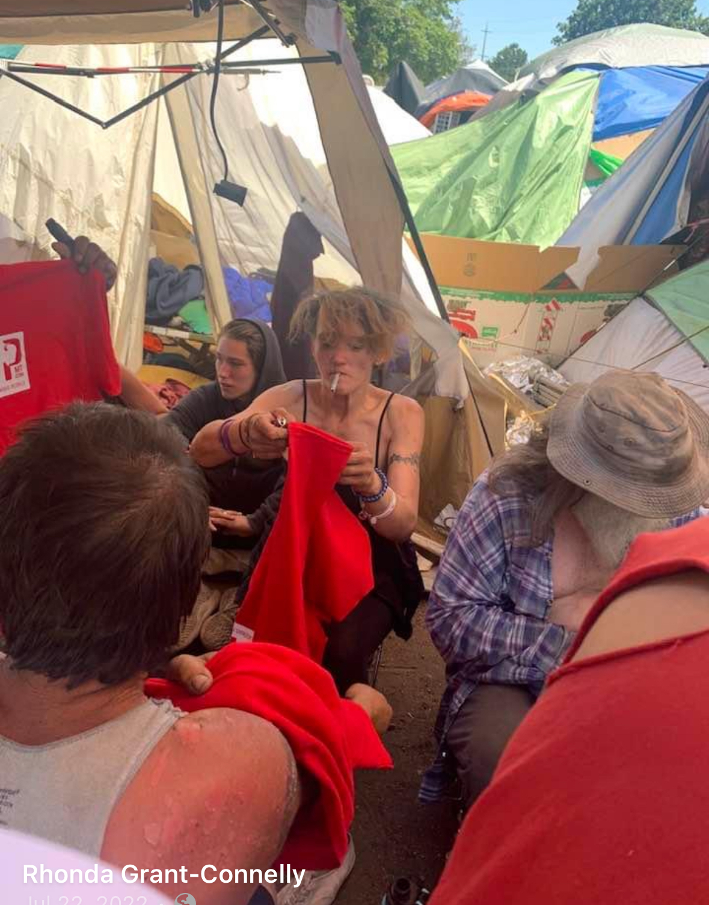
- 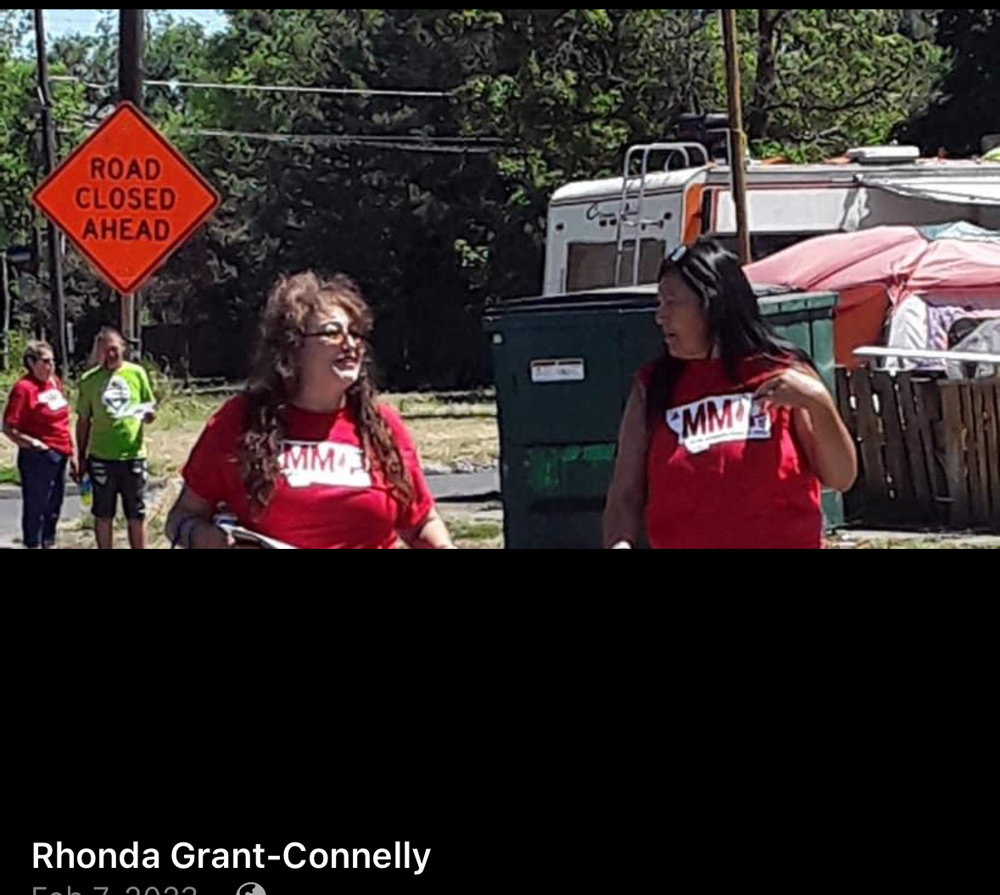

Our team believes that every person is important, and no task is too large.

Our goal is to significantly improve the mental health and well-being of all members of the community through counseling, support, awareness and advocacy.

The goal is to work collaboratively, with the focus being, to empower and offer healing pathways, to help support family members of MMIP are recognized as true experts, because our own lived experiences in the loss of a loved one.

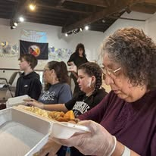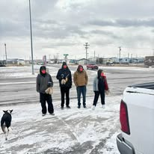

Our team believes that every person is important. We provide meals for our vulnerable (street people) and our community.

